We will give you a lot of travel happiness and a lot of fun.

Made possible by: Martijn Damme, Dirkje Thissen
Jun qi Chen, Levi Smits, Jessica van de Grint

Adress:
York road 49
9768 FA London

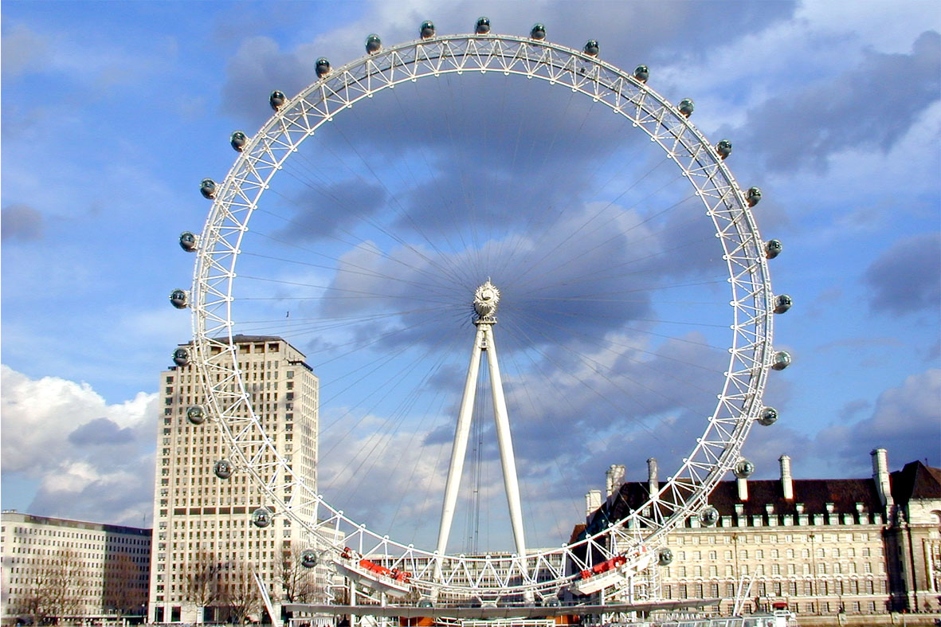

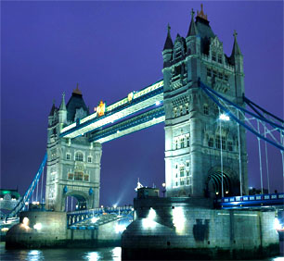

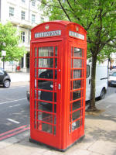

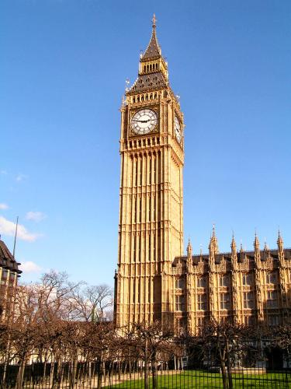
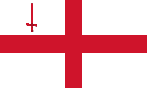

Hello and welcome in the leaflet about England. We’re very happy that you have made the choice to book a holiday by our Tourist Information Office.
In this guide book we will tell you everything about the English culture and other nice things that a tourist has to know! So don’t wait and read here everything about it!
Down here you can see the content.

We hope that you enjoy your vacation so much that you don’t want to go home☺.

England general Page 3, 4

How to travel to London? Page 5, 6

How to travel in London? Page 7, 8

Hotels Page 9, 10
11, 12, 13, 14
Food Page 15, 16

Places of interest in London Page 17, 18,

Places of interest in England Page 19, 20, 21

Events Page 22, 23
2
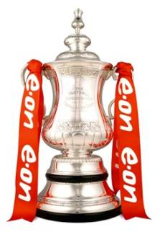
Sport: FA Cup Final
15 may
Wembley Stadium brings the FA Cup Final, with passion fought since 1872. Today begins the competition in November with a 700 teams that the same dream share: the cup keep here in Wembley Stadium on May
Metro Wembley Park or Wembley Central
Address Wembley Stadium, Stadium Way, Wembley HA9 OWS

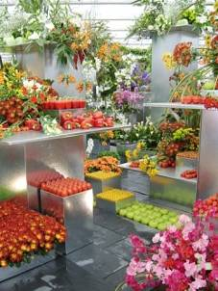
Lifestyle: Chelsea Flower Show
25-29 may
This year annually gardener's paradise as always, a party of colours and shapes that attract thousands of visitors to imaginative and innovative garden designs can be seen in the 11 acres of the Royal Hospital in Chelsea - a wonderland of flowers that the public can explore.
Metro Sloane Square
Address Royal Hospital, Royal Hospital Rd, London SW3 4S

23

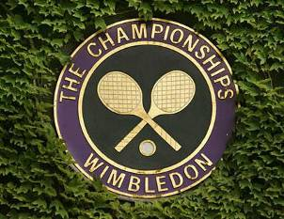
Sport: Wimbledon Lawn Tennis Championship 2010
21 June – 4 July
The biggest tennis tournament of the World. Wimbledon, it goes this year again of start as the peak of the Grand Slam Circuit. His history and traditions drawing all the best players on, and the best sets all of the time are playing here
Metro Southfields
Address the Lawn Tennis Association, Church Road, London SW19 5AE
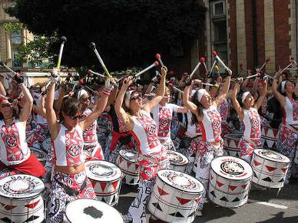
Festival: Notting Hill Carnival
29-30 august
Dance the calypso together with a half million other people on the famous Notting Hill Carnival. Fantastic floats rides by the neighbourhood and powerful sound systems bring loud music all day.
Metro Notting Hill
Address Notting Hill, London
22

History
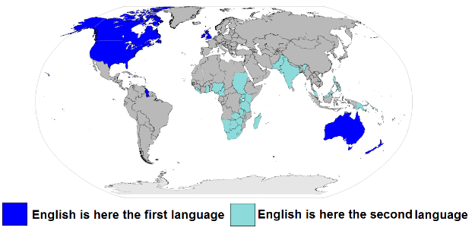
The history of London goes 2000 years back. During this time they were struck not only by the plague but also by an economic crisis. Today London is one of the four traditional metropolises considered, along with Paris, Tokyo and New York City. The city has 7,5 million habitants. They have the largest population of the European Union. London has not always been the capital of England, York was the first capital of London.

The Pound
In England we don’t pay with a Euro or a Dollar but we pay with a pound. Everybody in Great Britain is paying with the pound. One hundred pence is one pound, one pence is a eurocent.

Language
In England we speak English
Because English is so widely spoken, it has often been referred to as a "world language". English is not an official language in most countries, it is currently the language most often taught as a foreign language around the world.

3

Cuisine
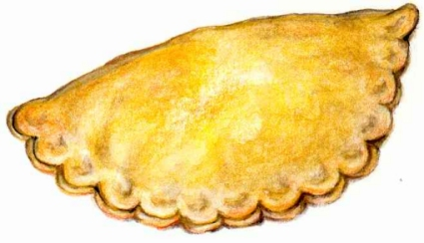
British food has traditionally been based on beef, lamb, pork, chicken and fish and generally served with potatoes and one other vegetable. The most common and typical foods eaten in Britain include the sandwich, fish and chips, pies like the cornish pasty,trifle and roasts dinners. Some of our main dishes have strange names like Bubble & Squeak and Toat in the hole

This is the flag of England
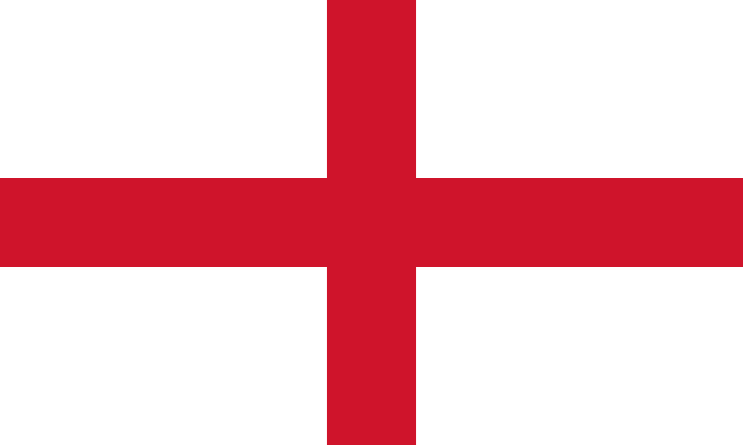

Place of London on a map
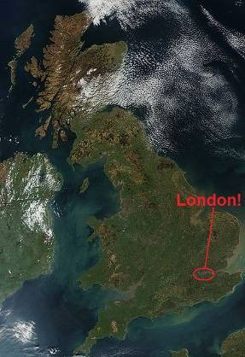

4
You can look at the beautiful gardens of this house.
Prices:
Children, five to sixteen years old: two pound and twenty pence.
Adults, fore pound and forty pence.

Public transport:
Tube: Hampstead
Rail: Hampstead Heath

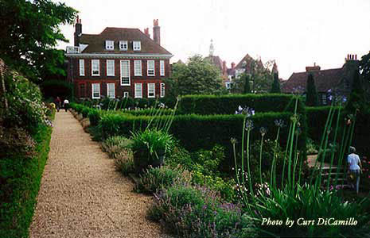

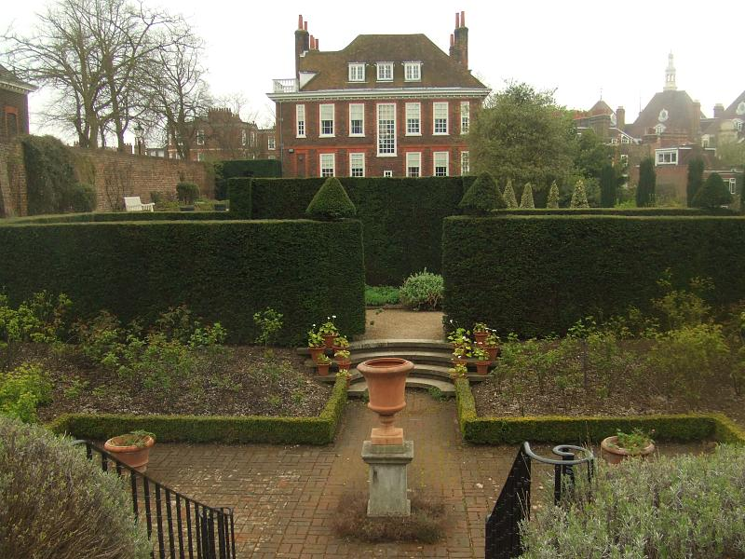

21

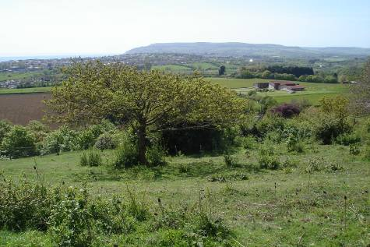
The name of the Isle of Wight says it all, it’s is an Island. The Isle of Wight is a perfect place to have a picnic. There are a lot of old cafes where you can drink something.

The price is up to you. Do you want go to the Isle of Wight, than you must be going by boat. The price when you go with the boat is then pound for return.

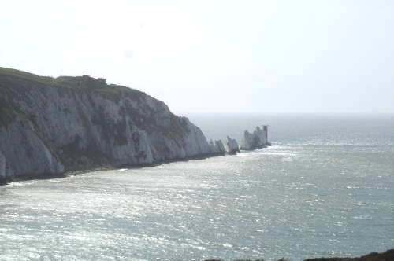
When you go with the boat you can see the white clives of Dover. You can take pictures! It is very special.
It has a beautiful view.

The Fenton is a museum for everyone!
You can see the old keyboards in the Fenton house.
You can see the collection of Embroidery Work, porcelain and furniture.
The harpsichords and spinets are still used. 20

For those coming from the continent we recommend the shortest crossing by ferry; Calais to Dover. You will get the best prices for both short and long stay returns, the most salings and a chance to stretch your legs and have something to eat. Dover to Calais 5 day returns for a car including passengers start from around 50 pound.

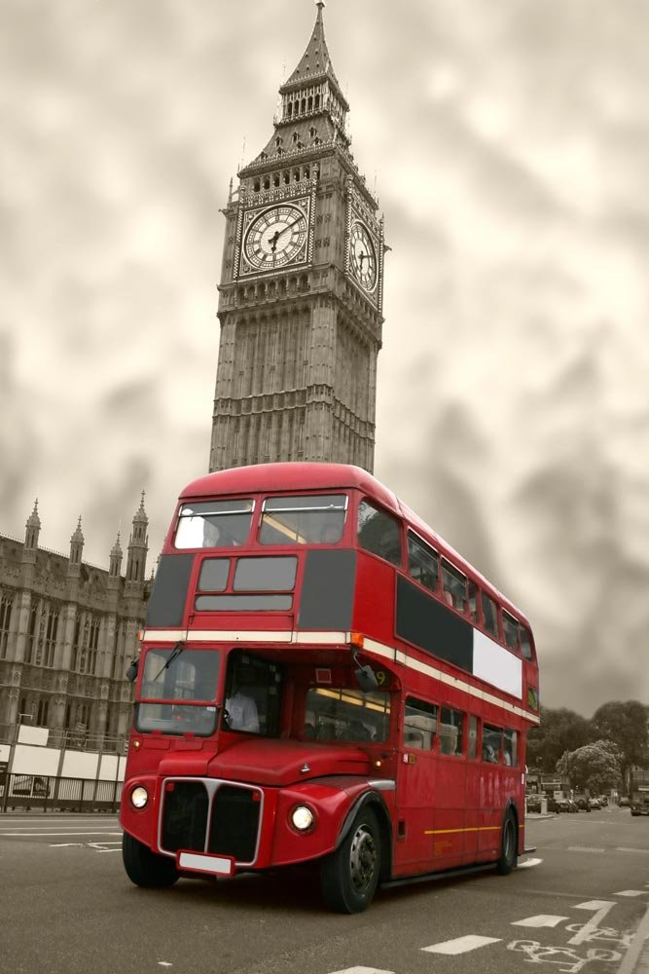
They can be cramped, they can be late and they are tediously boring, but long distance coach journeys do have their advantages. Convenient, because you can travel direct from all major European cities. Cheap; the bus is the backpacker's saviour. Cheerful, hey it can be a good place to meet fellow travellers, man.

5

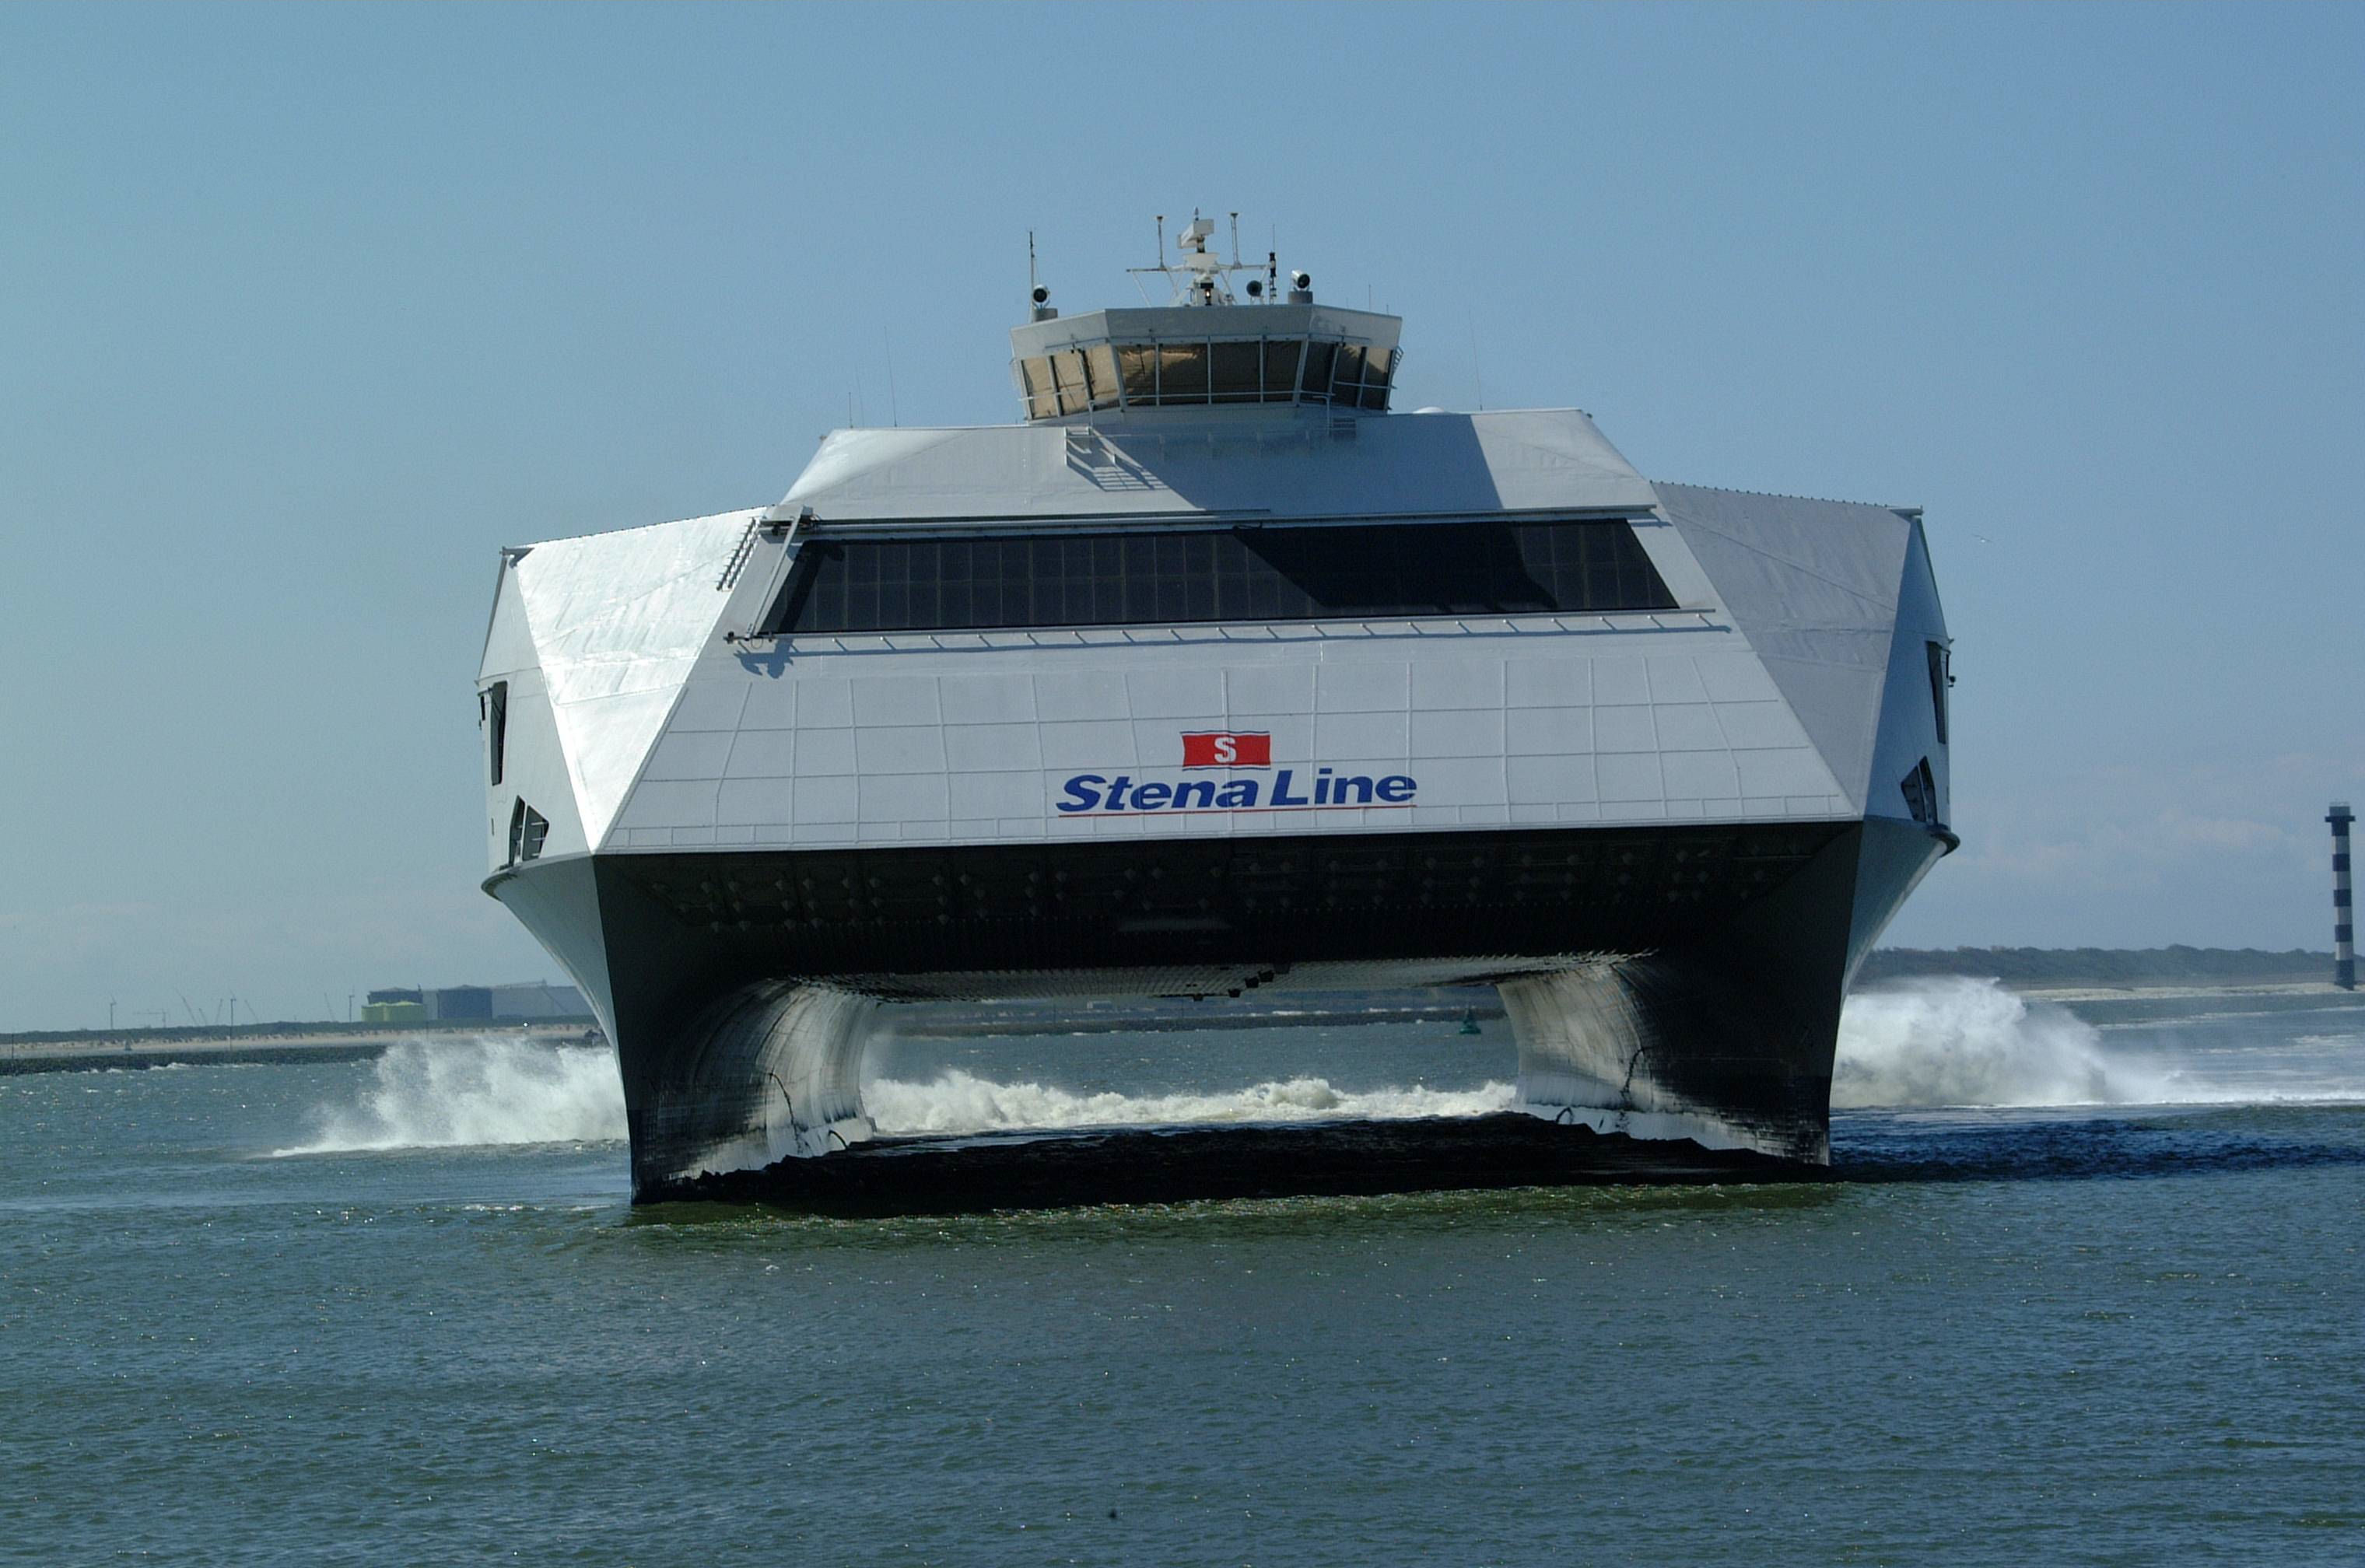
For some ferries will be their first choice, for others there is no alternative. Good news is ferries are now modern, safe and offer many amenities. Plus there are now really fast ships operating on selected routes. Prices range from bargain (10 pound or so for foot passengers) to expensive (300 pound return for plush club class overnight cabin & vehicle plus passengers).
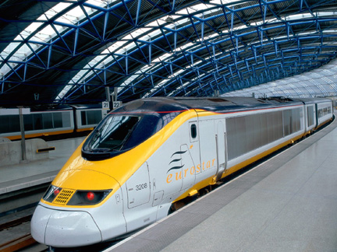
Direct services run from Paris and Bruxelles to London Waterloo. Journey time is currently three and a half hours city to city. The tunnel will not be the cheapest option but can be an exciting part of your journey. Over 20 miles long, the tunnel has been planned since Napoleon's time. For travel from beyond Paris and Bruxelles connect to Euro star at either of these cities or Lille (Northern France). 6

The official name of the Kew gardens is Royal Botanic Kew gardens. It is in the south-west of London. The Kew garden is a park with beautiful plants. The Kew gardens have a lot of rare plants.
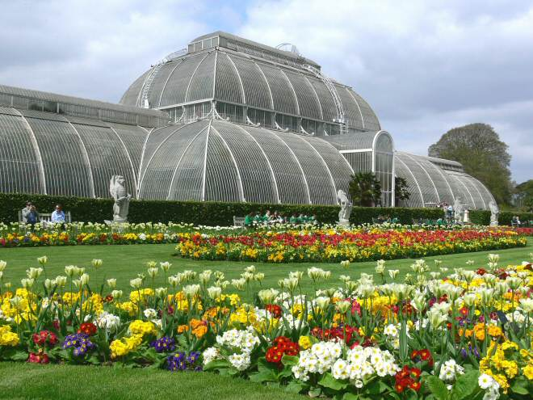
Prices:
Adults: thirteen pound and fifty pence.
Children under seventeen years: FREE
Student with ID, Senior citizen 60+: eleven pound and fifty pence.

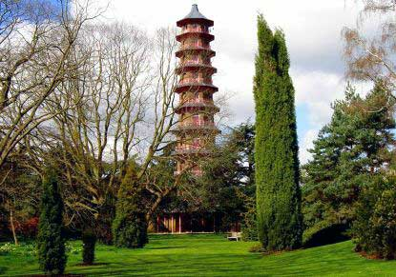
Public transport: You can go with the tube or the Rail.

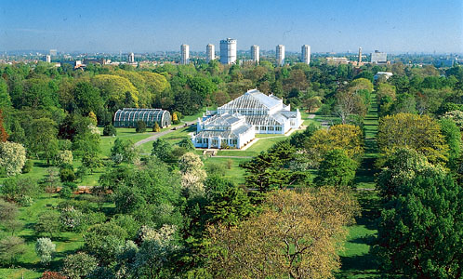

19

The official name of the Buckingham palace is Buckingham house. It’s called Buckingham because it was the property of count Buckingham.
The hole palace has 775 rooms of al those rooms are 78 bathroom.
It’s also very interesting to see the change of gard it will takes 45 minutes and it’s very funny to see.
Cost: £ 5.50 for a child, £ 8,50 for an adult.
Rules: In this palace don’t may come any dogs so there’s a dog house where your dog can stay for two hours for £ 2,00.

Big Ben is the name of the big clock in the Palace of Westminster.
The clock only makes noise at the hour. The clock is built in the year 1858, you can see that it’s very old, but also very beautiful to see. The weight of the clock is: 13.195 kg.

Cost: for the palace of Westminster tour £ 7,00 for young and old, for the Big Ben tour £6,00, and for a tour for both places £ 11,00.
Rules: NO dogs allowed!!

Oxford Street is the big shopping avenue of London. This street is very, very long. In one year more then 2 million people visit the street. There are a lot of malls where you can take a look and maybe even can buy something.
Cost: You can make it as much you likeJ 17
Rules: not applicable.
. 18

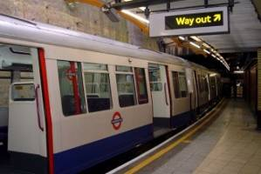
The underground of London, is the fastest way to go from A to B. Zones 1 and 2 cover the Centrum of London and the suburb walk to zone 6. Outside the peak hour travel you advantageous and avoids you busy crowds.

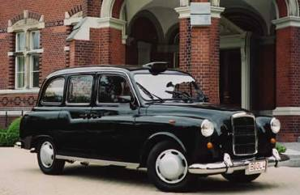
You can travel with the famous black taxi (black cab). You can take a taxi from the big station or you can hold a taxi on the street (with an orange lamp is indicated or the taxi is available). Chauffeurs most succeed for their test "The Knowledge" and know every street in London. Sometime seem they to think everything to know; you can then also easy take a chat about every subject.

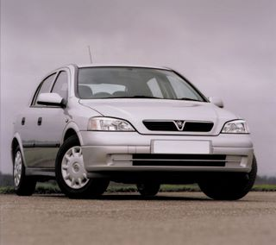
You can in the district of the attractions in the London’s center parking, but watch of the red C-signs, that the congestion zones indicate. You must within 24 hours £ 8 meeting. This can be done online or at designated shops. Street signs indicate whether a parking or paid parking for permit holders and the possible time constraints. 7

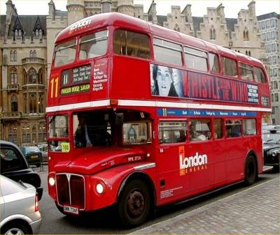
All buses are low-floor vehicles. The red London’s biplane and the new harmonic abuses are cheaper and often minder busy than the underground. In a peak hour is this sure not the fastest way of travel, but from a biplane do you have a nice view. Some lines ride 24 hours a day. There are 2 Heritage-routes that be drive with the iconic Routemaster-busses out the years 60. Line 15 ride of Trafalgar Square to Tower Hill and line 9 from the Royal Albert Hall to Aldwych.

If you choose to walk for some journeys in London you’ll discover there are lots of attractions. There are 109 journeys between central London and the Tube stations. It is also a fantastic way to unexpected attractions to discover. Walk along the South Bank for the famous view on the Houses of Parliament, the London Eye and Tate Modern.
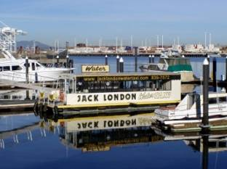

River travel
Take the river travel and see London on the river. Popular sails are Westminster to Kew, Hampton Court, Waterloo and Greenwich. 8
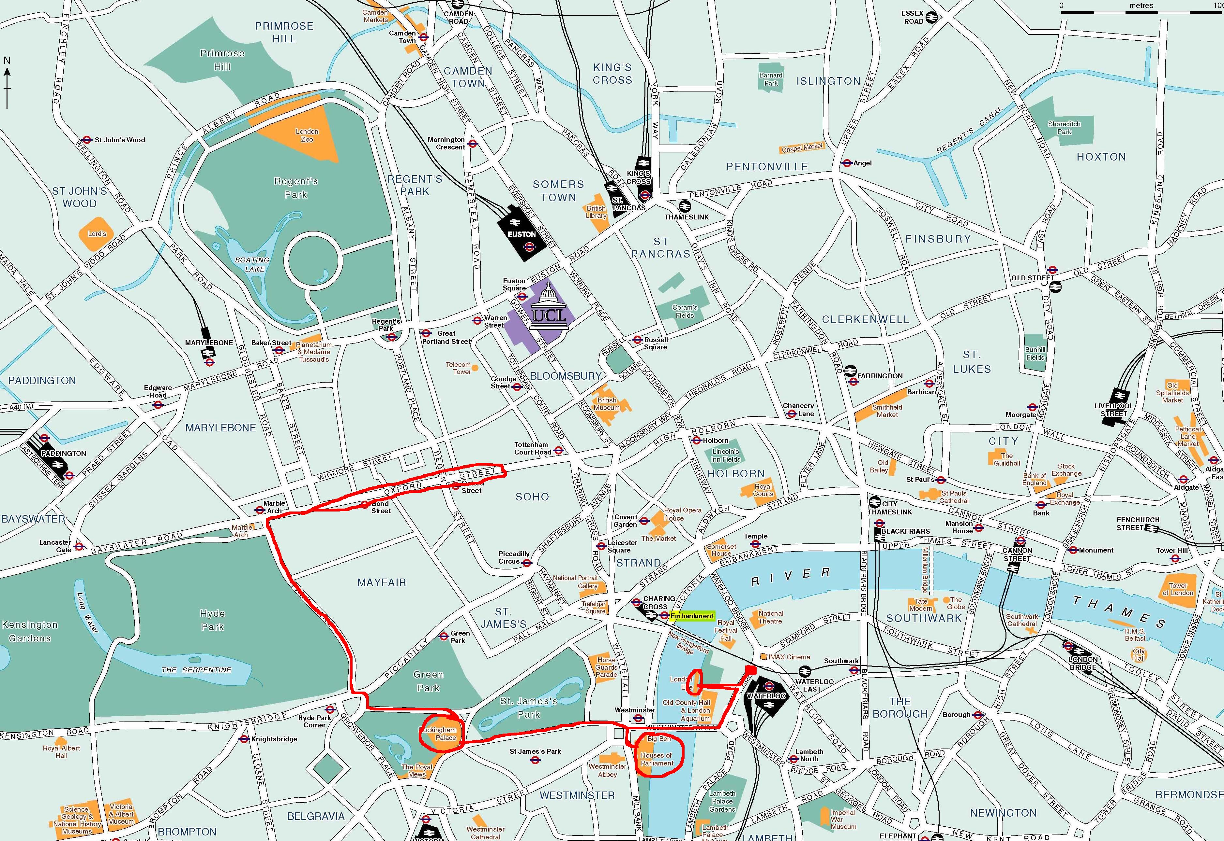
There are a lot of things that you can do in London, so why don’t you go sightseeing for one day? There are a lot of places of interest. I’ll tell you about some of them: Tower Bridge, Tower of London, London Dungeon, London Eye, Buckingham Palace, Oxford Street, Big Ben. There are two possibilities; a guided tour with places that are already chosen, or make your own unguided tour with the places you like. Down here you can see the places where you go to if you choose the guided tour, but you may have to choose one little thing; Do you want to go to The Buckingham palace or The Westminster palace and the Big Ben? There will be a guide that can tell you a lot of things about the places of interest and there will be an original English bus.

The London eye is a big Ferris wheel in London. It’s built it in 1999. Then it was the biggest Ferris wheel of the whole world. Currently a Ferris wheel in Singapore the biggest.
The London eye is built on the south bank of the Theems, across the palace of Westminster.
The London eye is built because of the millennium in 2000 and because of that they also call it ‘the millennium wheel.
In one year the London eye turns 6000 rounds.
One ride takes 27 minutes.
Costs: £ 15,00 for an adult £ 12,00 for a child. Rules: It’s very important to know that a child (under 12 years) needs to be accompanied by an adult.

For the fish you need the following
- 1 kg of white fish fillets
- Worcester Sauce
- Lemon juice
- Spicy mustard
- Flower

Wash the fish under cold water and pat it dry.
Cut into small portions. Worcester sauce Mix with
Lemon juice and a little mustard. Remove the fish
Pieces go through and dust them with flour. Remove
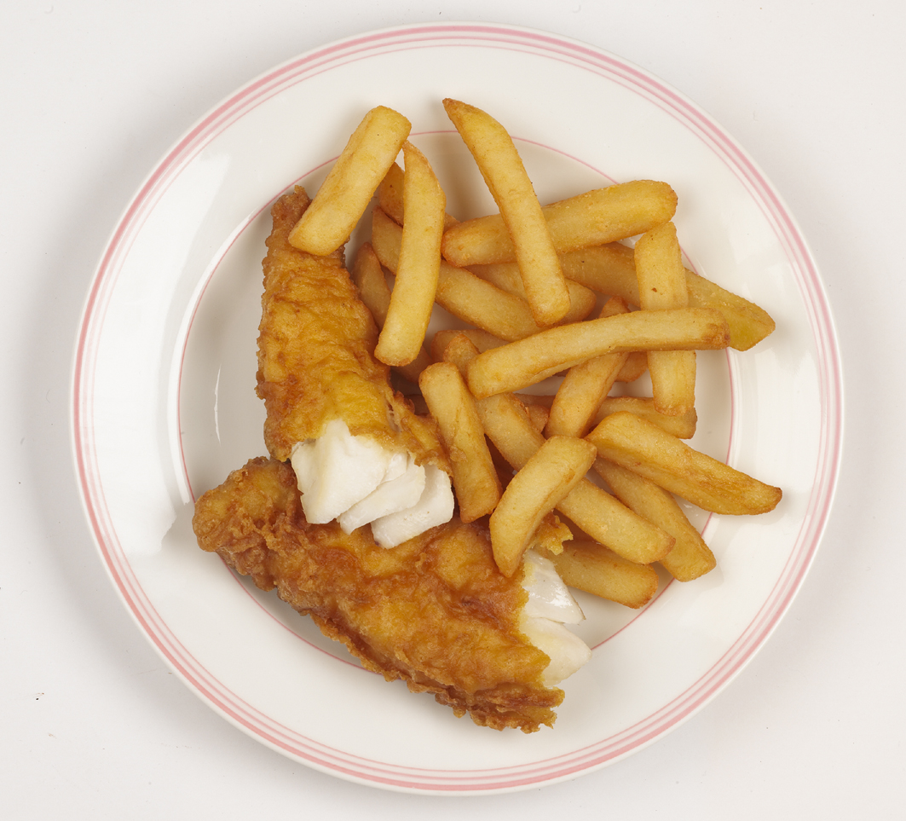
the pieces of fish in the batter and fry them in just 4
to 5 minutes until golden.
Chips can do the frying or get your snack. British food
like salted chips sprinkled with vinegar. A very special
experience. Be sure to do if you dare!

Here you see a picture of fish and chips.
16

Hotel rules.
Check in.
From 14:00 till 23:00.
Check out.
From 11:00 till 17:00.
Cancellations.
First day free. The days that following will be charged.
Accepted credit cards.
American express, visa, switch.
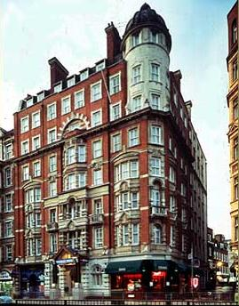
Waverly house hotel.
134 Southhampton Row.
Bloomsbury.
WC1B 5AF London.

Hotel facilities.
General.
Bar, restaurant, newspapers, gay friendly, air conditioning reception 24 hour, non-smoking room, room for people with disabilities, lift, safe, heating, luggage storage.
Internet.
No internet.

Hotel rules.
Check in. 9
From 14:00 till 23:00.
Check out.
From 11:00 till 17:00.
Cancellations.
Cancellations of 3 days in advance will not be charged. The days that following will be charged.
Accepted credit cards.
American express, visa, switch, maestro, diners, master card.
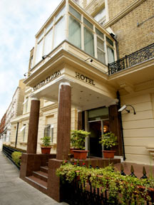
Oliver plaza hotel.
33 Trebovir Rd, Earls Court.
Earls Court.
SW5 9NF London.

Hotel facilities.
General.
Restaurant, reception 24 hour, non-smoking room, lift, safe, heating, luggage storage.
Activities.
Billiards.
Internet.
No internet.

10

Fish and chip is a typical British meal.

What do you need to make fish and chips:
- 200 gram flour
- 1 tablespoon of sugar
- 4 tablespoons of beer
- one fourth teaspoon of salt
- 2 egg yolks
- 6 tablespoons of milk
- 6 tablespoons of water
- 2 egg whites

Sift the flour over a scale, add sugar and stir everything together. Make a well in the center and pour in the beer, together with the salt and egg yolks. Stir well.
Mix milk with water and it slowly to the batter. Stir until a thick smooth mass. Let this half hours. Beat the egg whites until stiff and fold it gently into the batter.
15

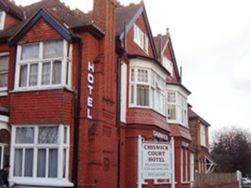
Chiswick court hotel B&B.
39 Bath Road.
W4 1LJ London.

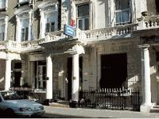
Athena hotel B&B.
110 Sussex Gardens.
Paddington.
W2 1UA London.

14
Hotel rules.
Check in.
From 14:00 till 22:00.
Check out.
From 11:00 till 18:00.
Cancellations.
Cancellations of 2 days in advance will not be charged. The days that following will be charged.
Accepted credit cards.
American express, visa, switch, maestro, master card.

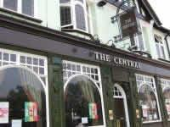
The central hotel.
150 Barking Road.
Upton Park.
E6 3BD London.

Hotel facilities.
General.
Bar, non-smoking room, garden.
Activities.
Billiards, darts.
Internet.
Free. 11

Hotel rules.
Check in.
From 14:00 till 23:00.
Check out.
From 07:00 till 11:00.
Cancellations.
Cancellations of 7 days in advance will not be charged. The days that following will be charged.
Accepted credit cards.
Visa, switch, maestro, master card, JCB, solo.

12

More accommodation places.

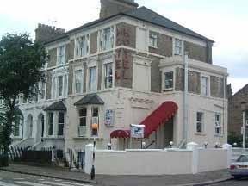
London guest house.
167 Horn Lane.
Acton.
W3 6PP London.

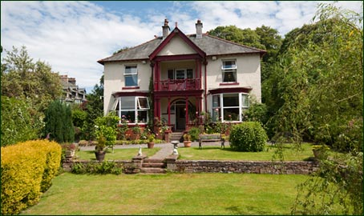
Hazel wood guest house.
127 Boston Manor Road.
TW8 9JR Brentford.

13

